***Chemistry***

**7: Chemical Bonding and Molecular Structure**

**7.4: Formal Charges and Resonance**

45. Write resonance forms that describe the distribution of electrons in each of the molecules or ions given below:

(a) sulfur dioxide, SO2

(b) carbonate ion, 

(c) hydrogen carbonate ion,  (C is bonded to an OH group and two O atoms)

(d) pyridine:

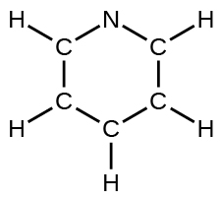

(e) the allyl ion:

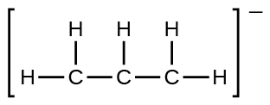

Solution

(a)

L:\Clients\Connexions\CONNEX130016_Chemistry\02_Working_Files\C07_Chemical Bonding and Molecular Geometry\99_Current_Art\JPEG\CNX_Chem_07_04_Ques2ansa_img.jpg;

(b)

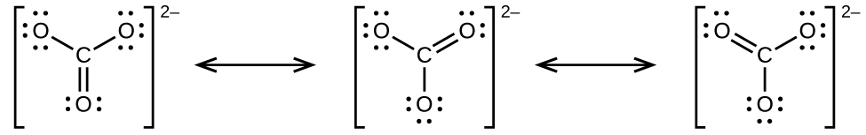;

(c)

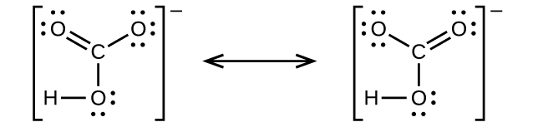;

(d)

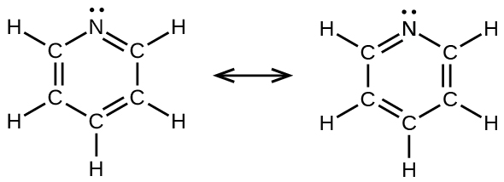;

(e)

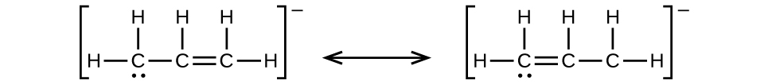

47. Sodium nitrite, which has been used to preserve bacon and other meats, is an ionic compound. Write the resonance forms of the nitrite ion, .

Solution

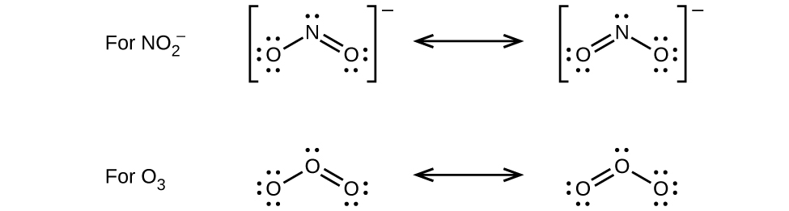

49. Write the Lewis structures for the following, and include resonance structures where appropriate. Indicate which of the three has the strongest carbon-oxygen bond.

(a) CO2

(b) CO

Solution

(a)

L:\Clients\Connexions\CONNEX130016_Chemistry\02_Working_Files\C07_Chemical Bonding and Molecular Geometry\99_Current_Art\JPEG\CNX_Chem_07_04_Ques13ansb_img.jpg

(b)

L:\Clients\Connexions\CONNEX130016_Chemistry\02_Working_Files\C07_Chemical Bonding and Molecular Geometry\99_Current_Art\JPEG\CNX_Chem_07_04_Ques13ansc_img.jpg

CO has the strongest carbon-oxygen bond, because there are is a triple bond joining C and O. CO2 has double bonds, and carbonate has 1.3 bonds.

51. Determine the formal charge of each element in the following:

(a) HCl

(b) CF4

(c) PCl3

(d) PF5

Solution

|  |  |  |  |  |  |
| --- | --- | --- | --- | --- | --- |
|  | Element | Bonding Electrons | Nonbonded Electrons | Valence Electrons | Formal Charge |
| (a) | H  Cl | 1  1 | 0  6 | 1  7 | 0  0 |
| (b) | C  F | 4  1 | 0  6 | 4  7 | 0  0 |
| (c) | P  Cl | 3  1 | 2  6 | 5  7 | 0  0 |
| (d) | P  F | 5  1 | 0  6 | 5  7 | 0  0 |

53. Calculate the formal charge of chlorine in the molecules Cl2, BeCl2, and ClF5.

Solution

|  |  |  |  |  |  |
| --- | --- | --- | --- | --- | --- |
|  | Element | Bonding Electrons | Nonbonded Electrons | Valence Electrons | Formal Charge |
| Cl2 | Cl | 1 | 6 | 7 | 0 |
| BeCl2 | Be  Cl | 2  1 | 0  6 | 2  7 | 0  0 |
| ClF5 | Cl  F | 5  1 | 2  6 | 7  7 | 0  0 |

55. Draw all possible resonance structures for each of the compounds below. Determine the formal charge on each atom in each of the resonance structures:

(a) O3

(b) SO2

(c) 

(d) 

Solution

(a)

;

(b)

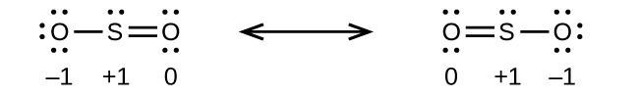;

(c)

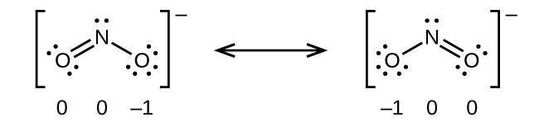;

(d)

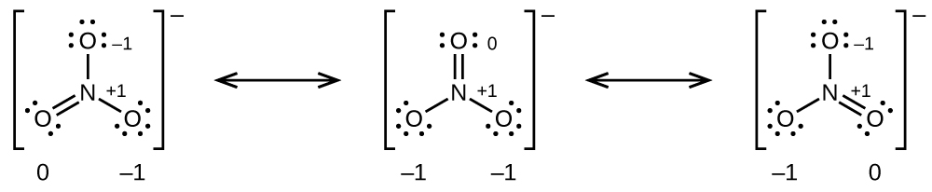

57. Based on formal charge considerations, which of the following would likely be the correct arrangement of atoms in hypochlorous acid: HOCl or OClH?

Solution



The structure with formal charges of 0 is the most stable and would therefore be the correct arrangement of atoms.

59. Draw the structure of hydroxylamine, H3NO, and assign formal charges; look up the structure. Is the actual structure consistent with the formal charges?

Solution

The structure that gives zero formal charges is consistent with the actual structure:

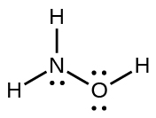

61. Write the Lewis structure and chemical formula of the compound with a molar mass of about 70 g/mol that contains 19.7% nitrogen and 80.3% fluorine by mass, and determine the formal charge of the atoms in this compound.

Solution

There are 19.7 g N and 80.3 g F in a 100.0-g sample:

.

The empirical formula is NF3 and its molar mass is 71.00 g/mol, which is consistent with the stated molar mass.

Oxidation states: N = +3, F = –1.

Formal charges: N = 0, F = 0:

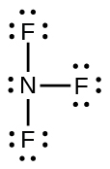

63. Sulfuric acid is the industrial chemical produced in greatest quantity worldwide. About 90 billion pounds are produced each year in the United States alone. Write the Lewis structure for sulfuric acid, H2SO4, which has two oxygen atoms and two OH groups bonded to the sulfur.

Solution

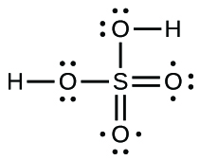

This resource file is copyright 2015, Rice University. All Rights Reserved.